Bachelor of Education (Elementary) &

Bachelor of Education (Secondary) STEM

Unit Plan Template

Unit Title: | Immigration and Multiculturalism | Number of Lessons | 10 lessons | Time  (in weeks): | 10 weeks
Name: | Ashley McCabe | Subject(s): | Social studies, language arts, art | Grade(s): | 5

Rationale
This unit is important because it covers important historic content around immigration and multiculturalism. Canada thrived and is what it is today with the help of immigrants and multiculturalism. Canada is a multicultural country and it is important that we educate students on the historic events that took place and slowly led Canada to be what it is today. It is as well important that the very upsetting events, such as Japanese internment camps and Africville are covered and learnt about in schools.

Overview:
This unit will work to cover early immigration to Canada, what drove people to immigrate, how Canada attracted and brought in immigrants. We will learn about Africville, linking the country through the Trans-Canada Railway, lots around Japanese Canadian internment camps (having a guest speaker who is very knowledgeable on the internment camps that took place in Lillooet – the town we live in and as well taking a field trip to one of the historic Japanese internment camps in Lillooet).

CORE COMPETENCIES
Communication | Thinking | Personal & Social
Communicating  - Connecting and engaging with others  - Focusing on intent and purpose  Collaborating  - Working collectively  - Supporting group interactions | Critical thinking  - Questioning and investigating  - Analyzing and critiquing  Creative thinking  - Creating and innovating | Positive personal and cultural identity  - Understanding relationships and cultural contexts  Personal awareness and responsibility  - Well-being  Social responsibility  - Building relationships  - Valuing diversity

BIG IDEAS
(multiple subject areas for integrated unit)
Subject Name: Social Studies | Subject Name: English Language Arts | Subject Name: Art
- Canada’s policies and treatment of minority peoples have negative and positive legacies.  - Immigration and multiculturalism continue to shape Canadian society and identity. | - Questioning what we hear, read, and view contributes to our ability to be educated and engaged citizens. | - Works of art influence and are influenced by the world around us.

LEARNING STANDARDS
Curricular Competencies | Content
Social Studies  - Use Social Studies inquiry processes and skills to — ask questions; gather, interpret, and analyze ideas; and communicate findings and decisions  - Sequence objects, images, and events, and recognize the positive and negative aspects of continuities and changes in the past and present (continuity and change)  - Differentiate between intended and unintended consequences of events, decisions, and developments, and speculate about alternative outcomes (cause and consequence) | Social Studies  - The changing nature of Canadian immigration over time  - The development and evolution of Canadian identity over time  - Past discriminatory government policies and actions, such as the Head Tax, the Komagata Maru incident, residential schools, and internments
English Language Arts  - Use a variety of comprehension strategies before, during, and after reading, listening, or viewing to guide inquiry and deepen understanding of text  - Respond to text in personal and creative ways  - Exchange ideas and perspectives to build shared understanding | English Language Arts  - Reading strategies  - Sentence structure and grammar  - Oral language strategies
Art  - Explore connections to identity, place, culture, and belonging through creative expression  - Express, feelings, ideas, and experiences through the arts | Art  - Personal and collective responsibility associated with creating, experiencing, or presenting in a safe learning environment

Prerequisite Concepts and Skills:
- Make value judgements about events, decisions, or actions, and suggest lesson that can be learned
- Recognize the causes and consequences of events, decisions, or developments (cause and consequence)
- Ask questions, make inferences, and draw conclusions about the content and features of different types of sources
- Use developmentally appropriate reading, listening, and viewing strategies to make meaning
- Engage actively as listeners, viewers, and readers, as appropriate, to develop understanding of self, identity, and community
- Create artistic works collaboratively and as an individual, using ideas inspired by imagination, inquiry, experimentation, and purposeful play

Teacher Preparation Required:
Lesson # | Teacher Preparation Required
Lesson 1 | Early Immigration to Canada  - Ask students & have a conversation around – What do we know and wonder about immigration.  - Show YouTube clip: https://www.youtube.com/watch?v=Yo4ViKqT7Cw  - Short discussion about immigrants and immigration:  - When Canada became a country on July 1, 1867, there was a lot of work to be done and a lot of opportunities to offer.  - Goal: Prime Minister John A. McDonald wanted to see the Canadian borders stretch “from sea to sea”.  - There was one important thing that had to happen to make this goal achievable!  - Thoughts?  - A lot of workers!  - Lots of farmers, lots of constructions laborers and lots of people willing to settle the land!  - Problem: Canada did not have enough people for this.  - Thoughts?  - The government planned to attract immigrants  - Short discussion/brainstorm on – How do you think the government and Canada attracted immigrants.  - Short discussion/brainstorm on – What were some of the reasons people immigrated to Canada  - Activity:  - With iPad and in pairs, you will analyze the 6 posters that are found on this website: https://thediscoverblog.com/tag/immigrations-posters/  - Begin working on your poster with a partner – not much will get done during this session on posters  - Posters must include:  - A targeted audience  - Your names  - Pictures that would persuade settlers to come to the Canadian West  - Phrases that would persuade settlers to come to the Canadian West
Lesson 2 | Continued work on posters  - Continued work on posters – complete posters  - Poster reflection form  - Hand in posters and reflection forms
Lesson 3 | Africville  - Discussion: What is Africville?  - Africville was a primarily Black community located in Halifax.  - Many of the first settlers of Africville in Halifax were formerly enslaved African Americans from the Thirteen Colonies, Black Loyalists who were freed by the crown during the American Revolutionary War and War of 1812.  - Black racism was a core reason for Africville and this racism pushed Black Settlers to settle there in Africville.  - What happened to Africville? The city of Halifax demolished Africville and all of the residents were relocated. The residents had no say in any of this.  - Show YouTube clip: https://www.youtube.com/watch?v=k5IDXVyhu0g  - Students read the handout and complete the worksheet  - Reading:  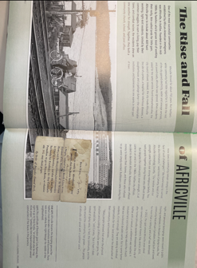  - Worksheet – breakdown the 2 parts of the question for the class and review the questions before students work on the worksheet:  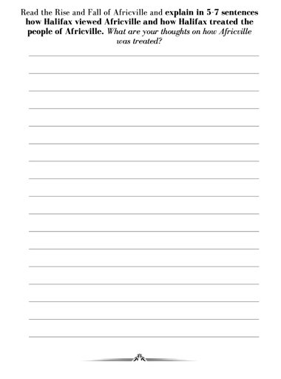
Lesson 4 | Linking the Country  What is the Canadian Pacific Railway (CPR)?  - Show the show video The Story of the Canadian Pacific Railway (0:50). Explain that “transcontinental” means across the continent.  - Ask: How would building a railway help build the country of Canada?”  - (Brought settlers and immigrants, transported goods and materials, connected eastern and western Canada)  - Project the website CP Connecting Canada. Scroll through the images in the timeline. Explain that building the railways is one of Canada’s greatest feats of engineering.  - Ask: How did the geography (land) of Canada make building a railway challenging? (Swamps, bogs, rivers, prairies, and mountains)  How did the CPR affect Indigenous people?  - Explain that First Nations and Métis groups were living on the land that the railway was going to be built on.  - Read aloud the section The Northwest Rebellion in Building the Trans-Canada Railroad.  Article link: https://www.vcn.bc.ca/pmmuseum/Programs/Building%20the%20Trans%20Canada%20Railroad.pdf  - Ask:  - Why were First Nations and Métis unhappy about the railway?  - How did the railway help the Canadian government control Indigenous peoples?  - Why would Indigenous people not see the railway as a positive symbol of Canadian unity?  - Provide students with the reading Building the Trans-Canada Railroad and the handout “CPR 5W+H”  Worksheet “CPR 5W + H”:  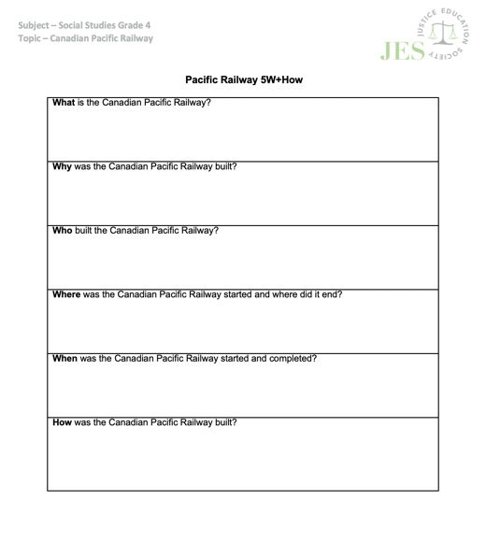
Lesson 5 | Connecting Canada – Canadian Railway Continued: How did Chinese workers contribute to building the CPR  - Explain that building the railway in BC was difficult because of the many mountains. Building tunnels through the mountains was dangerous, and the most dangerous jobs were often done by Chinese workers.  - Show the Heritage Minute video Nitro. -- https://www.youtube.com/watch?v=EE3ISzalVuo  - Ask why Chinese workers would have been willing to do such dangerous work.  - Read aloud the section Chinese Workers in BC in Building the Trans-Canada Railroad.— within the article from last week – Ask:  - What was life like for the Chinese railroad workers?  - What challenges did the Chinese railroad workers experience?  - How did the Chinese railroad workers help shape British Columbia and Canada?  - Show the image The Last Spike.  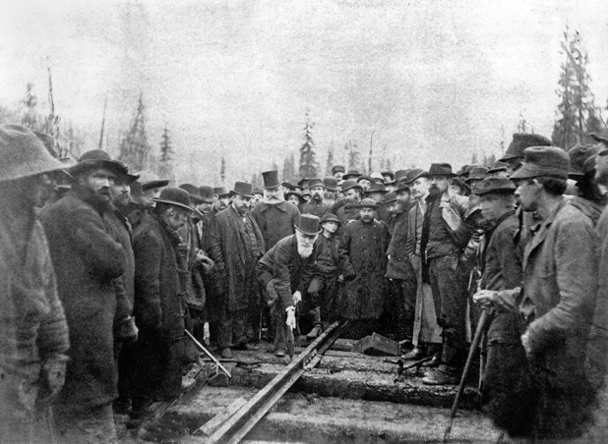  https://www.thecanadianencyclopedia.ca/en/article/the-last-spike  - Ask:  - Who is shown in the picture? (Men who owned/managed the CPR company and white working men)  - Who is missing from the photograph? (There is not a single Chinese Canadian worker in the photograph. In fact, they were cleared from the area before the photo was taken.)  - Why might this be? (Discuss the anti-Asian racism of the time.)
Lesson 6 | Japanese Canadian Internment Camps  - Question: Does anyone know what Japanese internment camps were? Or know anything about them?  - Show this clip: https://www.youtube.com/watch?v=5_rk3RP5KQs  Activity:  - Read “Flags” by Maxine Trottier & Paul Morin  - Writing time! - Students will write a brief few sentences on the prompt: How did the forced relocation and internment of Japanese Americans during world war ll impact Japanese lives? As well as, drawing an image of how they picture Mr. Hiroshi’s backyard.  - Class brainstorm of some writing ideas for the question above  - Class K-W-L chart – focus on the wonders (questions) for when the guest speaker comes in the next social studies session
Lesson 7 | Guest Speaker  Mariko Kage – Local lady in Lillooet -- Her father was involved in the Japanese Internment Camps  Discussing: History of JC internment locally and provincially/our local 2018/2022 JC internment/east Lillooet Memorial projects
Lesson 8 | Field Trip Day!  Field trip to a local internment camp in Lillooet
Lesson 9 | Blog Article on Local Internment Camp  - Class discussion and refresher session on the previous weeks field trip  - Students will be creating their own “blog” worksheet from the field trip  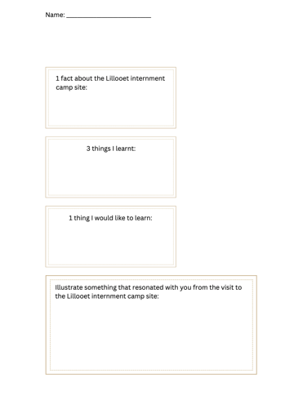  - Students complete the worksheet to the best of their ability
Lesson 10 | Jeopardy Game Day!  - Based all around the content that we covered over the past 9 lessons  - Students will be grouped into teams  - I will make up the jeopardy game once we have covered all of the content and the guest speaker has been in and spoken to the class

Cross-Curricular Connections:
This unit could be connected to a unit around:
- Indigenous histories in Lillooet
- Racial events that have occurred in the past
- Shared history and friendship between local St’at’imc people in Lillooet BC and Japanese/Chinese internees and beyond our local cross-cultural relations, how historically in BC, Chinese Canadians, Chinese migrants developed relations with Indigenous peoples in BC

This unit could be connected to a lesson around:
- Discrimination
- Art where students learn Origami paper folding
- The Copper Wall project with Chief Michelle Edwards of Cayoosh Creek band (Sekw’el’was)

Aboriginal Connections/ First Peoples Principles of Learning:
- Learning is embedded in memory, history, and story. – Guest speaker (Mariko Kage) sharing stories of the histories and memories she has gained through her family about the Japanese Internment camps.

- Learning involves patience and time. – Learning about history can be a lot. There are so many stories to be told and things to be leant about. Many complex things. Students must be patient and understand that learning past stories, events and happenings takes time.

- Learning involves recognizing that some knowledge is sacred and only shared with permission and/or in certain situations. – Mariko Kage will be sharing stories about the Miyazaki Heritage House in Lillooet. She will be sharing knowledge and giving me permission to share with my students.

- Learning involves generational roles and responsibilities. – Mariko Kage coming in to speak with the class about the Japanese Canadian internment camps in Lillooet is allowing students to learn through generational roles and responsibilities. Mariko is enacting the roles and responsibilities of sharing the stories and happenings of the Japanese Canadian internment camps in Lillooet.

Universal Design for Learning (UDL)
- MULTIPLE MEANS OF REPRESENTATION –
- Videos
- Class brainstorms on the board
- Orally sharing
- Guest speaker
- Readings
- K-W-L chart

- MULTIPLE MEANS OF ACTION AND EXPRESSION –
- Group posters
- Worksheets
- Jeopardy game
- Field trip

- MULTIPLE MEANS OF ENGAGEMENT –
- Field trip
- Guest speaker
- Videos
- Group poster creation
- Worksheets
- Class brainstorms on the board
- Readings
- Jeopardy game
- Listening to a book being read
- K-W-L chart

Differentiated Instruction (DI):
- Students who enjoy/learn best by visual means of learning –
- YouTube videos
- Picture book being read
- Pictures
- Creating posters
- Class brainstorms on the board
- Jeopardy
- K-W-L chart

- Students who enjoy/learn best by kinesthetic means of learning –
- Creating posters
- Field trip
- Worksheets
- Jeopardy

- Students who enjoy/learn best by auditory means of learning –
- Listening to the teacher
- Listening to the guest speaker
- Listening to peers during group discussions
- Listening to stories being read
- Listening to stories being told

- Students who enjoy/learn best by writing means of learning –
- Worksheets/written responses
- Partner posters

Overview of Lessons:

Lesson 1
Name &Time (Minutes Allotted): | Early Immigration to Canada – 45 minutes
Learning Standards: Curricular Competencies | - Ask questions, corroborate inferences, and draw conclusions about the content and origins of a variety of sources, including mass media (evidence)  - Use Social Studies inquiry processes and skills to — ask questions; gather, interpret, and analyze ideas; and communicate findings and decisions  - Examine relationships between the arts and the wider world  - Interpret and communicate ideas using symbols and elements to express meaning through the arts
Learning Standards: Content | - The changing nature of Canadian immigration over time  - The development and evolution of Canadian identity over time  - Image development strategies
Instructional Objectives | Students will be able to:  - Engage and participate in the lesson  - Begin working on a poster that would target an audience and attract settlers to Canada
Assessment: | 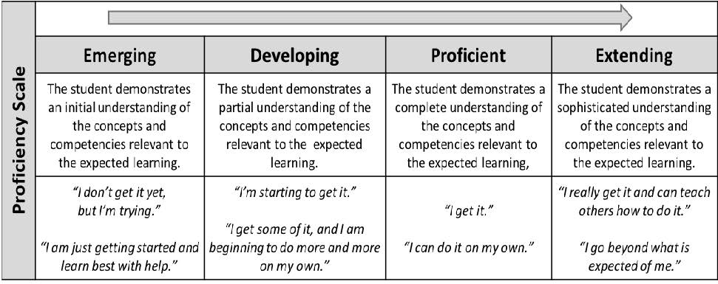  Proficiency scale would be connected to the ‘students will be able to” – target an audience and attract settlers to Canada with appropriate pictures and phrases  - Emerging – student demonstrates an initial understanding of using pictures and phrases to target a certain audience that would work to attract settlers to Canada.  - Developing – student demonstrates a partial understanding of using pictures and phrases to target a certain audience that would work to attract settlers to Canada.  - Proficient – student demonstrates a complete understanding of using pictures and phrases to target a certain audience that would work to attract settlers to Canada.  - Extending – student demonstrates a sophisticated understanding of using pictures and phrases to target a certain audience that would work to attract settlers to Canada.
Teaching Strategies: | - Prepared/organized.  - Emphasize raising hands throughout group discussion, if there are any questions, or thoughts to share.  - Emphasize respect for yourself and those around you during class discussions.  - Encourage creativity.  - Encourage having a plan before diving into it.  - Continue to assist around the classroom and demonstrate approachable characteristics – enthusiastic, upbeat, welcoming, helpful etc.
Materials: | - Computer and smartboard  - Construction paper  - Pencils and erasers  - Colors  - iPad

Lesson Activities:
Introduction/Hook: | - Ask students & have a conversation around – What do we know and wonder about immigration.  - Show YouTube clip: https://www.youtube.com/watch?v=Yo4ViKqT7Cw  - Short discussion about immigrants and immigration:  - When Canada became a country on July 1, 1867, there was a lot of work to be done and a lot of opportunities to offer.  - Goal: Prime Minister John A. McDonald wanted to see the Canadian borders stretch “from sea to sea”.  - There was one important thing that had to happen to make this goal achievable!  - Thoughts?  - A lot of workers!  - Lots of farmers, lots of constructions laborers and lots of people willing to settle the land!  - Problem: Canada did not have enough people for this.  - Thoughts?  - The government planned to attract immigrants  - Short discussion/brainstorm on – How do you think the government and Canada attracted immigrants.  - Short discussion/brainstorm on – What were some of the reasons people immigrated to Canada  - Activity:
Body: | - With iPad and in pairs, you will analyze the 6 posters that are found on this website: https://thediscoverblog.com/tag/immigrations-posters/  - Once analyzed, students will be paired up  - Discuss that posters must include:  - A targeted audience  - Your names  - Pictures that would persuade settlers to come to the Canadian West  - Phrases that would persuade settlers to come to the Canadian West  - Begin working on your poster with a partner – not much will get done during this session on posters
Closure: | - Clean-up  - Collect posters  - Students seated ready for further instruction

Lesson 2
Name &Time (Minutes Allotted): | Early Immigration to Canada Continued… – 45 minutes
Learning Standards: Curricular Competencies | - Ask questions, corroborate inferences, and draw conclusions about the content and origins of a variety of sources, including mass media (evidence)  - Use Social Studies inquiry processes and skills to — ask questions; gather, interpret, and analyze ideas; and communicate findings and decisions  - Examine relationships between the arts and the wider world  - Interpret and communicate ideas using symbols and elements to express meaning through the arts
Learning Standards: Content | - The changing nature of Canadian immigration over time  - The development and evolution of Canadian identity over time  - Image development strategies
Instructional Objectives | Students will be able to:  - Create a poster that would target an audience and attract settlers to Canada with appropriate picture and phrases
Assessment: | Proficiency scale would be connected to the ‘students will be able to” – target an audience and attract settlers to Canada with appropriate pictures and phrases  - Emerging – student demonstrates an initial understanding of using pictures and phrases to target a certain audience that would work to attract settlers to Canada.  - Developing – student demonstrates a partial understanding of using pictures and phrases to target a certain audience that would work to attract settlers to Canada.  - Proficient – student demonstrates a complete understanding of using pictures and phrases to target a certain audience that would work to attract settlers to Canada.  - Extending – student demonstrates a sophisticated understanding of using pictures and phrases to target a certain audience that would work to attract settlers to Canada.
Teaching Strategies: | - Prepared/organized.  - Emphasize raising hands throughout group discussion, if there are any questions, or thoughts to share.  - Emphasize respect for yourself and those around you during class discussions.  - Encourage creativity.  - Encourage having a plan before diving into it.  - Continue to assist around the classroom and demonstrate approachable characteristics – enthusiastic, upbeat, welcoming, helpful etc.
Materials: | - Posters  - Pencils and erasers  - Colors  - iPad (possibly)

Lesson Activities:
Introduction/Hook: | - Ask students if they remember what we did last SS class  - Review the guidelines of the poster  - Check for understanding  - Check for any confusion  - Continued work session on posters  - This is a session with the goal to complete the posters
Body: | - Continued work on posters – complete posters  - Poster reflection form
Closure: | - Hand in posters  - Hand in reflection forms  - Clean up your area  - Sit quietly awaiting further direction

Lesson 3
Name &Time (Minutes Allotted): | Africville – 45 minutes
Learning Standards: Curricular Competencies | - Use Social Studies inquiry processes and skills to — ask questions; gather, interpret, and analyze ideas; and communicate findings and decisions  - Ask questions, corroborate inferences, and draw conclusions about the content and origins of a variety of sources, including mass media (evidence)  - Apply a variety of thinking skills to gain meaning from texts  - Respond to text in personal and creative ways  - Communicate in writing using paragraphs and applying conventions of Canadian spelling, grammar, and punctuation
Learning Standards: Content | - Human rights and responses to discrimination in Canadian society  - The changing nature of Canadian immigration over time  - Sentence structure and grammar  - Writing processes
Instructional Objectives | Students will be able to:  Describe how Halifax viewed and treated people of Africville
Assessment: | Evaluate students on their description of how Halifax viewed and treated people of Africville in relation to this proficiency scale  - Emerging – Student demonstrates an initial understanding of how Halifax viewed and treated people of Africville.  - Developing – Student demonstrates a partial understanding of how Halifax viewed and treated people of Africville.  - Proficient – Student demonstrates a complete understanding of how Halifax viewed and treated people of Africville.  - Extending – Student demonstrates a sophisticated understanding of how Halifax viewed and treated people of Africville.
Teaching Strategies: | - Prepared/organized.  - Emphasize raising hands throughout group discussion, if there are any questions, or thoughts to share.  - Emphasize respect for yourself and those around you during class discussions.  - Encourage creativity.  - Continue to assist around the classroom and demonstrate approachable characteristics – enthusiastic, upbeat, welcoming, helpful etc.
Materials: | - Reading:  - Worksheet:  - Pencil and eraser  - Computer and smartboard

Lesson Activities:
Introduction/Hook: | What is Africville?  - Africville was a primarily Black community located in Halifax.  - Many of the first settlers of Africville in Halifax were formerly enslaved African Americans from the Thirteen Colonies, Black Loyalists who were freed by the crown during the American Revolutionary War and War of 1812.  - Black racism was a core reason for Africville and this racism pushed Black Settlers to settle there in Africville.  - What happened to Africville? The city of Halifax demolished Africville and all of the residents were relocated. The residents had no say in any of this.  - Show YouTube clip: https://www.youtube.com/watch?v=k5IDXVyhu0g
Body: | - Students read the handout and complete the worksheet  - Worksheet – breakdown the 2 parts of the question for the class and review the questions before students work on the worksheet:  - Students work on worksheets
Closure: | - Collect worksheets  - Students’ clean-up their areas  - Sit quietly and await further instruction

Lesson 4
Name &Time (Minutes Allotted): | Linking the Country – 45 minutes
Learning Standards: Curricular Competencies | - Use Social Studies inquiry processes and skills to — ask questions; gather, interpret, and analyze ideas; and communicate findings and decisions  - Ask questions, corroborate inferences, and draw conclusions about the content and origins of a variety of sources, including mass media (evidence)  - Apply a variety of thinking skills to gain meaning from texts
Learning Standards: Content | - Human rights and responses to discrimination in Canadian society  - The changing nature of Canadian immigration over time  - Sentence structure and grammar
Instructional Objectives | Students will be able to:  - Answer the questions thoughtfully on the Pacific Railway 5W+How worksheet showing understanding
Assessment: | I will be assessing students on their answers on the worksheet/their ability to respond to the worksheet questions correctly.  - Emerging – Student demonstrates an initial understanding when answering questions in regards to the Canadian Pacific Railway.  - Developing – Student demonstrates a partial understanding when answering questions in regards to the Canadian Pacific Railway.  - Proficient – Student demonstrates a complete understanding when answering questions in regards to the Canadian Pacific Railway.  - Extending – Student demonstrates a sophisticated understanding when answering questions in regards to the Canadian Pacific Railway.
Teaching Strategies: | - Prepared/organized.  - Emphasize raising hands throughout group discussion, if there are any questions, or thoughts to share.  - Emphasize respect for yourself and those around you during class discussions.  - Encourage creativity.  - Continue to assist around the classroom and demonstrate approachable characteristics – enthusiastic, upbeat, welcoming, helpful etc.
Materials: | - Worksheet:  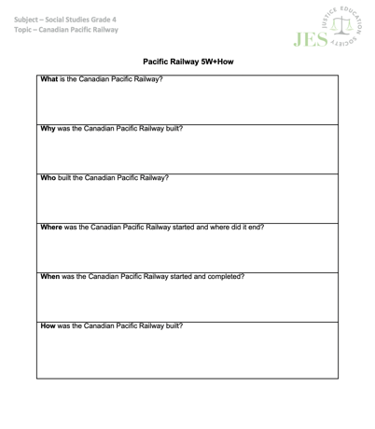  - Pencil and eraser  - Computer and smartboard  - Article

Lesson Activities:
Introduction/Hook: | - Show the show video The Story of the Canadian Pacific Railway (0:50). Explain that “transcontinental” means across the continent.  - Ask: How would building a railway help build the country of Canada?  - Looking for answer: (brought settlers and immigrants, transported goods and materials, connected eastern and western Canada)  - Project the website CP Connecting Canada. Scroll through the images in the timeline. Explain that building the railways is one of Canada’s greatest feats of engineering.  - Ask: How did the geography (land) of Canada make building a railway challenging? (Swamps, bogs, rivers, prairies, and mountains)  - Explain that First Nations and Métis groups were living on the land that the railway was going to be built on.  - Read aloud the section The Northwest Rebellion in Building the Trans-Canada Railroad.  - Article link: https://www.vcn.bc.ca/pmmuseum/Programs/Building%20the%20Trans%20Canada%20Railroad.pdf  - Ask/Discuss:  - Why were First Nations and Métis unhappy about the railway?  - How did the railway help the Canadian government control Indigenous peoples?
Body: | - Provide students with the reading Building the Trans-Canada Railroad and the handout “CPR 5W+H” – students work on worksheets
Closure: | - Collect worksheets  - Students’ clean-up their area  - Await further instruction

Lesson 5
Name &Time (Minutes Allotted): | Linking the Country Continued… – 45 minutes
Learning Standards: Curricular Competencies | - Use Social Studies inquiry processes and skills to — ask questions; gather, interpret, and analyze ideas; and communicate findings and decisions  - Ask questions, corroborate inferences, and draw conclusions about the content and origins of a variety of sources, including mass media (evidence)  - Apply a variety of thinking skills to gain meaning from texts
Learning Standards: Content | - Human rights and responses to discrimination in Canadian society  - The changing nature of Canadian immigration over time  - Sentence structure and grammar
Instructional Objectives | Students will be able to:  - Answer the questions thoughtfully on the Pacific Railway 5W+How worksheet showing understanding
Assessment: | I will be assessing students on their answers on the worksheet/their ability to insightfully answer the questions.  - Emerging – Student demonstrates an initial understanding when answering questions in regards to the Canadian Pacific Railway.  - Developing – Student demonstrates a partial understanding when answering questions in regards to the Canadian Pacific Railway.  - Proficient – Student demonstrates a complete understanding when answering questions in regards to the Canadian Pacific Railway.  - Extending – Student demonstrates a sophisticated understanding when answering questions in regards to the Canadian Pacific Railway.
Teaching Strategies: | - Prepared/organized.  - Emphasize raising hands throughout group discussion, if there are any questions, or thoughts to share.  - Emphasize respect for yourself and those around you during class discussions.  - Encourage creativity.  - Continue to assist around the classroom and demonstrate approachable characteristics – enthusiastic, upbeat, welcoming, helpful etc.
Materials: | - Worksheets from previous day  - Pencil and eraser  - Computer and smartboard

Lesson Activities:
Introduction/Hook: | - Explain that building the railway in BC was difficult because of the many mountains. Building tunnels through the mountains was dangerous, and the most dangerous jobs were often done by Chinese workers.  - Show the Heritage Minute video Nitro. -- https://www.youtube.com/watch?v=EE3ISzalVuo  - Ask why Chinese workers would have been willing to do such dangerous work.
Body: | - Read aloud the section Chinese Workers in BC in Building the Trans-Canada Railroad.— within the article from last week – Ask:  - What was life like for the Chinese railroad workers?  - What challenges did the Chinese railroad workers experience?  - How did the Chinese railroad workers help shape British Columbia and Canada?  - Show the image The Last Spike.  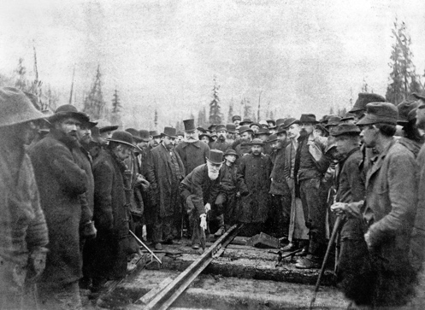  https://www.thecanadianencyclopedia.ca/en/article/the-last-spike  - Ask:  - Who is shown in the picture? (Men who owned/managed the CPR company and white working men)  - Who is missing from the photograph? (There is not a single Chinese Canadian worker in the photograph. In fact, they were cleared from the area before the photo was taken.)  - Why might this be? (Discuss the anti-Asian racism of the time.)  - Finish previous day’s worksheet
Closure: | - Collect worksheets  - Students’ clean-up their area  - Await further instruction

Lesson 6
Name &Time (Minutes Allotted): | Japanese Canadian Internment Camps – 45 minutes
Learning Standards: Curricular Competencies | - Use Social Studies inquiry processes and skills to — ask questions; gather, interpret, and analyze ideas; and communicate findings and decisions  - Ask questions, corroborate inferences, and draw conclusions about the content and origins of a variety of sources, including mass media (evidence)  - Apply a variety of thinking skills to gain meaning from texts  - Examine relationships between the arts and the wider world  - Interpret and communicate ideas using symbols and elements to express meaning through the arts
Learning Standards: Content | - Human rights and responses to discrimination in Canadian society  - The changing nature of Canadian immigration over time  - Sentence structure and grammar  - Image development strategies
Instructional Objectives | Students will be able to:  - Respond to the writing prompt – How did the forced relocation and internment of Japanese Americans during world war ll impact Japanese lives? – with insight
Assessment: | This proficiency scale will be used to evaluate the responses to – How did the forced relocation and internment of Japanese Canadians during world war ll impact Japanese lives?  - Emerging – Student demonstrates an initial understanding when responding to the question “how did the forced relocation and internment of Japanese Canadians during World War II impact Japanese lives”?  - Developing – Student demonstrates a partial understanding when responding to the question “how did the forced relocation and internment of Japanese Canadians during World War II impact Japanese lives”?  - Proficient – Student demonstrates a complete understanding when responding to the question “how did the forced relocation and internment of Japanese Canadians during World War II impact Japanese lives”?  - Extending – Student demonstrates a sophisticated understanding when responding to the question “how did the forced relocation and internment of Japanese Canadians during World War II impact Japanese lives”?
Teaching Strategies: | - Prepared/organized.  - Emphasize raising hands throughout group discussion, if there are any questions, or thoughts to share.  - Emphasize respect for yourself and those around you during class discussions.  - Encourage creativity.  - Continue to assist around the classroom and demonstrate approachable characteristics – enthusiastic, upbeat, welcoming, helpful etc.
Materials: | - Pencil and eraser  - Computer and smartboard  - Whiteboard and whiteboard marker/eraser  - Colors  - Book – “Flags” by Maxine Trottier & Paul Morin  - Worksheet:  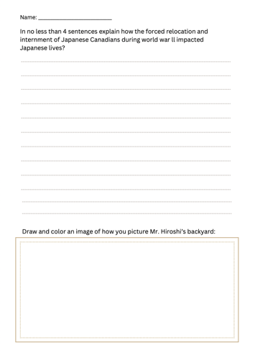

Lesson Activities:
Introduction/Hook: | - Question: Does anyone know what Japanese internment camps were? Or know anything about them?  - Show this clip: https://www.youtube.com/watch?v=5_rk3RP5KQs
Body: | - Read “Flags” by Maxine Trottier & Paul Morin  - Writing time! - Students will write a brief few sentences on the prompt: How did the forced relocation and internment of Japanese Americans during world war ll impact Japanese lives? As well as, drawing an image of how you picture Mr. Hiroshi’s backyard. – worksheet for this portion  - Class brainstorm – discovering ideas for the writing prompt  - Class K-W-L chart – focus on the wonders (questions) for when the guest speaker comes in next SS session.
Closure: | - Collect worksheet  - Students’ clean-up their area  - Await further instruction

Lesson 7
Name &Time (Minutes Allotted): | Lillooet Internment Camps – Guest Speaker Mariko Kage – 1 hour
Learning Standards: Curricular Competencies | - Use Social Studies inquiry processes and skills to — ask questions; gather, interpret, and analyze ideas; and communicate findings and decisions  - Ask questions, corroborate inferences, and draw conclusions about the content and origins of a variety of sources, including mass media (evidence)
Learning Standards: Content | - Human rights and responses to discrimination in Canadian society  - The changing nature of Canadian immigration over time
Instructional Objectives | Students will be able to:  - Engage, be respectful and learn new things from the guest speaker about the internment camps in Lillooet and write 2 important things they learnt on a piece of paper – **exit ticket**
Assessment: | I will be assessing students ability to record 2 important things they learnt from the guest speaker – **exit ticket**  - Emerging – Student demonstrates an initial understanding when recording 2 important things they learnt from the guest speaker.  - Developing – Student demonstrates a partial understanding when recording 2 important things they learnt from the guest speaker.  - Proficient – Student demonstrates a complete understanding when recording 2 important things they learnt from the guest speaker.  - Extending – Student demonstrates a sophisticated understanding when recording 2 important things they learnt from the guest speaker.
Teaching Strategies: | - Prepared/organized.  - Emphasize raising hands throughout group discussion, if there are any questions, or thoughts to share.  - Emphasize respect for yourself and those around you during class discussions.  - Encourage creativity.  - Continue to assist around the classroom and demonstrate approachable characteristics – enthusiastic, upbeat, welcoming, helpful etc.  - Emphasize respect for the guest that we have in the room.  - Emphasize asking questions.
Materials: | - Pencil and eraser  - Piece of paper

Lesson Activities:
Introduction/Hook: | - Review what appropriate and respectful listening skills are  - Introduce the guest speaker and what she will be talking about  - Emphasize that it is important to be engaged because you will have to write 2 important things that you learnt at the end of this SS lesson  - Guest speaker
Body: | Guest Speaker
Closure: | - Farewell and thanks to guest speaker

Lesson 8
Name &Time (Minutes Allotted): | Field trip to a Local Lillooet Internment Camp
Learning Standards: Curricular Competencies | - Use Social Studies inquiry processes and skills to — ask questions; gather, interpret, and analyze ideas; and communicate findings and decisions  - Ask questions, corroborate inferences, and draw conclusions about the content and origins of a variety of sources, including mass media (evidence)
Learning Standards: Content | - Human rights and responses to discrimination in Canadian society  - The changing nature of Canadian immigration over time
Instructional Objectives | Students will be able to:  - Follow instructions and learn
Assessment: | Assessing students’ ability to demonstrate appropriate behaviors and engagement as there will be an assignment following this field trip next day that requires students to have takeaways from the field trip
Teaching Strategies: | - Prepared/organized.  - Emphasize listening and engaging  - Share that it is important to listen as there will be an assignment following this field trip  - Maintain noise level and engagement
Materials: | - Permission slips signed  - Bus

Lesson Activities:
Introduction/Hook: | - Review expected behaviors  - Load the bus
Body: | Field trip
Closure: | - Back to school  - Everyone seated in their spots in the classroom

Lesson 9
Name &Time (Minutes Allotted): | Blog Article on Local Internment Camp
Learning Standards: Curricular Competencies | - Use Social Studies inquiry processes and skills to — ask questions; gather, interpret, and analyze ideas; and communicate findings and decisions  - Ask questions, corroborate inferences, and draw conclusions about the content and origins of a variety of sources, including mass media (evidence)  - Apply a variety of thinking skills to gain meaning from texts  - Respond to text in personal and creative ways  - Communicate in writing using paragraphs and applying conventions of Canadian spelling, grammar, and punctuation  - Examine relationships between the arts and the wider world  - Interpret and communicate ideas using symbols and elements to express meaning through the arts
Learning Standards: Content | - Human rights and responses to discrimination in Canadian society  - Sentence structure and grammar  - Writing processes  - The changing nature of Canadian immigration over time  - Image development strategies
Instructional Objectives | Students will be able to:  - Make conclusions and their own decisions following the field trip, recording their answers to questions on the worksheet
Assessment: | Using this proficiency scale to access students worksheets.  - Emerging – Student demonstrates an initial understanding of taking away knowledge from the field trip and applying it correctly to the worksheet.  - Developing – Student demonstrates a partial understanding of taking away knowledge from the field trip and applying it correctly to the worksheet.  - Proficient – Student demonstrates a complete understanding of taking away knowledge from the field trip and applying it correctly to the worksheet.  - Extending – Student demonstrates a sophisticated understanding of taking away knowledge from the field trip and applying it correctly to the worksheet.
Teaching Strategies: | - Prepared/organized.  - Emphasize raising hands throughout group discussion, if there are any questions, or thoughts to share.  - Emphasize respect for yourself and those around you during class discussions.  - Encourage creativity.  - Continue to assist around the classroom and demonstrate approachable characteristics – enthusiastic, upbeat, welcoming, helpful etc.  - Emphasize asking questions.
Materials: | - Pencil and eraser  - Colors  - Worksheet:

Lesson Activities:
Introduction/Hook: | - Ask – Who remembers last weeks’ field trip and what did we learn?  - Class discussion, sharing ideas and noting them on the board  - Help to refresh memories as it was a week ago that the field trip took place  - Introduce the assignment
Body: | - Students work on the assignment, filling out the boxes with their chosen answers  - Students must put illustrate a title for their worksheet, as well as, create illustrations on the page with color
Closure: | - Collect worksheets  - Students’ clean-up their area  - Await further instruction

Lesson 10
Name &Time (Minutes Allotted): | Jeopardy! – 45 minutes
Learning Standards: Curricular Competencies | - Use Social Studies inquiry processes and skills to — ask questions; gather, interpret, and analyze ideas; and communicate findings and decisions  - Ask questions, corroborate inferences, and draw conclusions about the content and origins of a variety of sources, including mass media (evidence)
Learning Standards: Content | - Human rights and responses to discrimination in Canadian society  - The changing nature of Canadian immigration over time
Instructional Objectives | Students will be able to:  - Work as a team and answers questions where the content has been covered over the past several weeks
Assessment: | - I will be assessing students’ ability to work in a team setting and be a good sport! – no large assessment for this activity – looking for good behaviors  - Notebook with names and I will make notes as I go – running record for the class
Teaching Strategies: | - Prepared/organized.  - Keep it fun.  - Maintain the noise level.  - Emphasize that it is okay to get a question wrong! This is how we learn.  - Emphasize respect for yourself and those around you during the class activity.  - Emphasize that when your group raises their hands, you must have an answer, you cannot just raise your hand to try to be first
Materials: | - Computer and smart board  - Paper and pencil if group wants it

Lesson Activities:
Introduction/Hook: | - Go over the expectations during jeopardy
Body: | Jeopardy
Closure: | - Clean-up  - Back to seating  - Await further instruction

Resources:
https://www.youtube.com/watch?v=5_rk3RP5KQs
https://www.thecanadianencyclopedia.ca/en/article/the-last-spike
https://www.vcn.bc.ca/pmmuseum/Programs/Building%20the%20Trans%20Canada%20Railroad.pdf
https://www.youtube.com/watch?v=EE3ISzalVuo
https://vimeo.com/214050454
https://www.youtube.com/watch?v=k5IDXVyhu0g
https://thediscoverblog.com/tag/immigrations-posters/
https://www.youtube.com/watch?v=Yo4ViKqT7Cw

Extensions to Unit:
This unit could be extended into lessons around:
- Other heritage/historical sites in Lillooet – hang-man’s tree, pit houses, the museum.
- Having indigenous elders (who are willing) to come in and share their stories about their times in residential schools.

Reflections and Revisions
N/A – Have not taught yet.

